|  |  |
| --- | --- |
| Data Analysis  PORTFOLIO | prepared by  RAJAT PANWAN |

# Professional Background

As a Regional Lead for a B2B eCommerce company, Udaan.com, I led a team of 14 market representatives in the apparel segment for Northern India. In this role, I executed and analyzed projects in coordination with marketing representatives, and regularly analyzed sales and operational data to support strategic decision making. I also coordinated multiple strategic pilot initiatives and assessed their utility for pan India execution.

Throughout my tenure, I successfully managed and mentored the 14-person team. I led daily team huddles, motivated the team, coached them in execution, trained them on system changes, and recognized exemplary performance. I understood business operations needs and accordingly set targets, communicated execution strategies to subordinates, and addressed problems faced by them in execution in the field. As a finance graduate, I pursued a Post Graduate diploma last year, and I am currently pursuing a Master of Computer Application from distance mode to enhance my technical knowledge. I have also completed various data analysis and data science courses.

With my experience in leading teams, analyzing sales data, and executing strategic initiatives, I am confident in my ability to excel in a data analyst role. My passion for data analysis, technical knowledge, and ability to lead and mentor teams make me an asset to any organization.

# Table of content

Professional Background 1

Table of content 2

1. Data Analytics Process 5

1.1 Description 5

1.2 Problem 5

1.3 Plan 5

1.4 Prepare 5

1.5 Process 5

1.6 Analyze 5

1.7 Share 6

1.8 Act 6

1.9 Conclusion 6

2. Instagram User Analytics 7

2.1 Description 7

2.2 Problem 7

2.3 Approach 7

2.4 Tech-Stack used 8

2.5 Findings 8

2.6 Data Analysis 12

2.7 Conclusion 13

3. Operation Analytics and Investigating Metric Spike 14

3.1 Description: 14

3.2 Problem: 14

3.3 Approach: 15

3.4 Tech Stack Used: 15

3.5 Findings: 15

3.6 Data Analysis: 21

3.7 Conclusion: 22

4. Hiring Process Analytics 23

4.1 Description: 23

4.2 Problem: 23

4.3 Approach: 23

4.4 Tech-Stack Used: 24

4.5 Findings: 24

4.6 Data Analysis: 27

4.7 Conclusion: 27

5. IMDB Movie Analysis 28

5.1 Description: 28

5.2 Problem: 28

5.3 Approach: 28

5.4 Tech-Stack Used: 29

5.5 Findings: 29

5.6 Data Analysis: 34

5.7 Conclusion: 34

6. Bank Loan Case Study 35

6.1 Description: 35

6.2 Problem: 35

6.3 Tech-Stack Used: 35

6.4 Findings: 36

6.5 Data Analysis: 40

6.6 Conclusion: 41

7. XYZ Ads Airing Report Analysis 42

7.1 Description: 42

7.2 Problem: 42

7.3 Approach: 43

7.4 Tech-Stack Used: 43

7.5 Findings: 43

7.6 Data Analysis: 51

7.7 Conclusion: 51

8. ABC Call Volume Trend Analysis 52

8.1 Description: 52

8.2 Problem: 52

8.3 Approach: 52

8.4 Tech-Stack Used: 53

8.5 Findings: 53

8.6 Data Analysis: 56

8.7 Conclusion: 57

appendix 58

# Data Analytics Process

## Description

Give the example(s) of such a real-life situation where we use Data Analytics and link it with the data analytics process. You can prepare a PPT/PDF on a real-life scenario explaining it with the process such as Plan, Prepare, Process, Analyze, Share and Act.

## Problem

To get 30% of the total calls which is 35396 because 30% calls are received at night. Then 35396 is divided into different time bucket according to the ratio given.

## Plan

Planning a trip is also a data analysis. Deciding the destination where we want to go, such as Beaches, Hill Stations, Towns and cities.

## Prepare

Check for the budget of the holiday I am willing to spend on the holiday.

## Process

Selecting the Destination. For example, if I decided to go on a hill station what it would be, like Himachal, North-East, J&K or foreign countries like Switzerland and Austria.

## Analyze

Now I will check the weather conditions, travelling duration and political condition are favorable or not.

## Share

Now communicate the idea to the travel agent, to find the best suitable destination under my budget.

## Act

Finally buying the plan from the agent according to my decision.

## Conclusion

In conclusion, data analysis has become an increasingly important aspect of our daily lives. From tracking our health and fitness goals to making informed financial decisions, data analysis can provide valuable insights that help us make better decisions. With the proliferation of data and the tools to analyze it, anyone can take advantage of the power of data analysis. By developing basic data analysis skills and using the right tools, we can gain a deeper understanding of the world around us and make more informed decisions in our personal and professional lives.

# Instagram User Analytics

## Description

In this project, MySQL commands are used to answer the questions asked by our investors and marketing team. The name of the database is “ig_clone” where I performed data manipulation on various tables suchas, comments, follows, likes, photo_tags, photos, tags and users. Joining data from multiple tables using Inner Join, Left Join, and Right Joins also performed.

## Problem

User analysis is the process by which we track how users engage and interact with our digital product (software or mobile application) in an attempt to derive business insights for marketing, product & development teams.

These insights are then used by teams across the business to launch a new marketing campaign, decide on features to build for an app, track the success of the app by measuring user engagement and improve the experience altogether while helping the business grow.  
You are working with the product team of Instagram and the product manager has asked you to provide insights on the questions asked by the management team.

## Approach

In this project I carefully read and understand the requirements and objective of the project. Then I go through the entire tables of the database to know tables attributes. In tables I use appropriate clauses such as Select, Order By, Group By and Where to extract the use insights. Once I had formulated the final query, I tested it thoroughly to ensure that it was correctly returning the desired results.

## Tech-Stack used

A Schema management system MySQL 8.0 is used to handle, store and modify and delete data and also store data in an organized way. In this process MySQL workbench is used which comes with MySQL.

## Findings

### Finding-1



After analyzing the available data and sorting it by date created, we get the insight that Darby_Herzog is the oldest user followed by Emilio_Bernier52 and Elenor88. We can reword these loyal customers.

### Finding-2





Based on the available data we can say that above query help us to identify the inactive users. I would suggest the company to remind these inactive users to start posting, by sending them promotional emails to post their first photo.

### Finding-3





Based on the available data we can say that photo with photo_id 145 get the most like on a single photo. We can reward the user to motivate other users to share more photos on the platform.

### Finding-4



Based on the available data and queries performed on the data we can say that Thursday is day of a week when most of the users register on. I want to suggest the company to launch ad campaign on Thursday would be more appropriate.

### Finding-5



Based on the available data and queries performed on the data we can say that the average user post is around 3.5. I would suggest the company to remind users to start posting by sending them promotional emails to post so average would increase.

### Finding-6





Based on the available data and queries performed on the data we can say that above list of the user likes every single photos on the site, so we can say that these are the fake accounts. We would suggest that Instagram should suspend these accounts.

## Data Analysis

Here are some insights and knowledge that I gained while working on Instagram User Analytics project such as understating of the SQL language and how to use it to retrieve and manipulate data in a database Develop an ability to design and execute complex queries using a range of SQL clauses, functions and operators Skills in data analysis and problem solving as the process of creating an SQL query often involves identifying patterns in the data.

We get the insight that Darby_Herzog is the oldest user followed by Emilio_Bernier52 and Elenor88. We can reword these loyal customers.

Identify the inactive users and suggest the company to remind these inactive users to start posting, by sending them promotional emails to post their first photo.

photo with photo_id 145 get the most like on a single photo. We can reward the user to motivate other users to share more photos on the platform.

## Conclusion

In conclusion, I would like to tell that after doing a thorough analysis we were able to derive the insights from the data and was able to plot various graphs using that data. The data that once looked useless became useful and helped to find out the users who is active and the inactive users. Analyzing the data proved helpful in finding various issues among the users.

# Operation Analytics and Investigating Metric Spike

## Description:

The project is about analyzing two different data sets related to the end to end operations of a company As a Data Analyst Lead at Microsoft, the aim is to derive insights from the given data sets and answer the questions asked by different departments of the company The first case study is related to job data and requires the calculation of various metrics, such as the number of jobs reviewed, throughput, percentage share of each language, and displaying duplicate rows The second case study is related to investigating metric spikes and requires the calculation of various metrics, such as weekly user engagement, user growth, weekly retention, weekly engagement per device, and email engagement metrics.

## Problem:

Operation Analytics is the analysis done for the complete end to end operations of a company. With the help of this, the company then finds the areas on which it must improve upon. You work closely with the ops team, support team, marketing team, etc. and help them derive insights out of the data they collect.

Being one of the most important parts of a company, this kind of analysis is further used to predict the overall growth or decline of a company’s fortune. It means better automation, better understanding between cross-functional teams, and more effective workflows.

Investigating metric spike is also an important part of operation analytics as being a Data Analyst you must be able to understand or make other teams understand questions like- Why is there a dip in daily engagement? Why have sales taken a dip? Etc. Questions like these must be answered daily and for that its very important to investigate metric spike.

You are working for a company like Microsoft designated as Data Analyst Lead and is provided with different data sets, tables from which you must derive certain insights out of it and answer the questions asked by different departments.

## Approach:

To complete the project, I go through the data provided in each table and understood the relationships between them Next, I created a database metric_spike and tables using SQL queries Once the tables are created, I started performing the analysis by writing SQL queries to answer the questions asked in each case study Finally, compiled the results and insights gained from the analysis.

## Tech Stack Used:

A database management system MySQL 8.0 is used to handle, store and modify and delete data and also store data in an organized way In this process MySQL Workbench in used which comes with MySQL.

## Findings:

### Finding-1:





Based on available data and queries performed on it we can say that jobs reviewed per hour per day for November 2020 is 0.0111.

### Finding-2:





Throughput is the no. of events happening per second. Based on the available data here is the 7 day rolling average of throughput. 7 day rolling average is used to smoothing out the fluctuations, end make it easier to identify long term trend.

### Finding-3:





Based on the available data we can say that maximum content is in Persian language which is 37.5% and all of the other five language has 12.5% share.

### Finding-4:





Based on the available data we can say that their isn’t any duplicate rows in the data. Which is good for analysis.

### Finding-5:



From the above query we can calculate the user engagement per week to measure the activeness of a user. By measuring user engagement per week we can say if the user finds quality in a product/service.

### Finding-6:





This is how we can know what is the growth of the users for a particular product. Here user growth means amount of users growing over time for a product.

### Finding-7:





Based on the available data we can say that weekly retention of users-sign up cohort is increasing every week. On week 24 there is highest value of the users-sign up cohort, then it start to decrease.

### Finding-8:





Based on the above extract table we can say that weekly engagement per device is highest for “Macbook pro” followed by “Lenovo Thinkpad”. That means user finds quality in of the service on the “Macbook Pro” as compare to any other devices.

### Finding-9:





With help of the above email engagement matrix, we can say that most used email service is “email weekly digest” followed by “email opens”. In the above matrix email event is the total of all the email services.

## Data Analysis:

Here are some insights and knowledge that I gained while working on the project.

jobs reviewed per hour per day for November 2020 is 0.0111.

The maximum content is in Persian language which is 37.5% and all of the other five language has 12.5% share.

There aren’t any duplicate rows in the data. Which is good for analysis.

## Conclusion:

In conclusion, I would like to tell that after doing a thorough analysis we were able to derive the insights from the data and was able to plot various graphs using that data. By providing valuable insights to different departments, we can help improve cross-functional understanding, workflows, and overall company growth.

# Hiring Process Analytics

## Description:

This project is about performing exploratory data analysis on a dataset provided by a company for their hiring process. As a lead data analyst, the task is to analyze the data to draw insights and provide recommendations to the hiring department. The project will involve understanding the data columns, checking for missing data, clubbing columns with multiple categories, checking for outliers, removing outliers, and drawing data summaries. The analysis will be performed using Excel or Google Sheets.

## Problem:

Hiring process is the fundamental and the most important function of a company. Here, the MNCs get to know about the major underlying trends about the hiring process. Trends such as- number of rejections, number of interviews, types of jobs, vacancies etc. are important for a company to analyse before hiring freshers or any other individual. Thus, making an opportunity for a Data Analyst job here too!

Being a Data Analyst, your job is to go through these trends and draw insights out of it for hiring department to work upon.

## Approach:

The first step in the project was to download the dataset provided by the Trainity and understand the data columns and data. This involved checking the format of the data, identifying the variables, and understanding the range of values for each variable. The next step was to check for missing data. After that, I checked for outliers and removed them using statistical methods. I then drew data summaries and analyzed the data to draw insights and provide recommendations.

## Tech-Stack Used:

The analysis was performed using Microsoft Excel. We used different Excel functions, such as COUNT, COUNTIFS, SUM, UNIQUE and AVERAGE to perform the analysis. We also used PIVOT TABLE, SLICER in Pivot Table, CHARTS and GRAPHS to visualize the data.

## Findings:

### Finding-1:

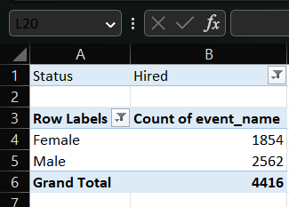

After plotting the pie chart for gender distribution, we can say that there is more males are applied for the job as compare to the females.

### Finding-2:

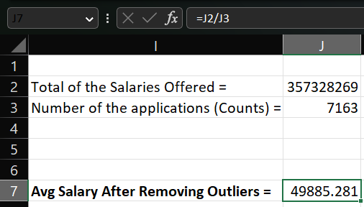

With the help of above table and formula used in the table we can say that the average salary offered to the applicants is around 50,000. This is the salary after removing the outliers from the data.

### Finding-3:

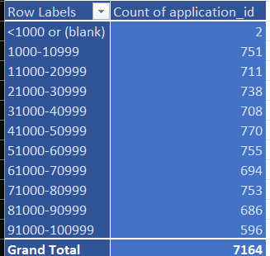

With the help of the above bar chart and table we can say that salary is distributed among the applicants equally, there is very less fluctuations in the number of applicants.

### Finding-4:

Based on the available data and pie chart drawn from that data, we can say that most of the applicants apply for the Operations Department followed by Service Department and sales Department. Least applied department is Human Resource Department.

### Finding-5:

Based on the data given we can say that C9 is the most applied post tier followed by C5 and then i7. The least applied post tier is m7, n10, n6, n9 which as only one applicant each.

## Data Analysis:

The analysis of the dataset provided insights into the hiring process of the company.

I found that the company had hired more males than females. The average salary offered by the company was found to be ₹49885.

I drew the class intervals for salary and found that the salary is equally distributed between ₹1000 to ₹100000.

The pie chart graph showed that most of the employees were working in the Operations department, followed by the Service department.

We also represented different post tiers using a chart and found that most of the employees were in C5 and C9 position

## Conclusion:

In conclusion, I would like to tell that after doing a thorough analysis we were able to derive the insights from the data and was able to plot various graphs using that data. The data that once looked useless became useful and helped to find out to whom be should hire more and in which department we should hire more employees. Analyzing the data proved helpful in finding various issues among the employees and their hiring process.

# IMDB Movie Analysis

## Description:

The aim of this project is to perform an analysis on a dataset containing information on various movies from IMDB. The dataset includes columns such as the director name, gross, genres, movie title, num voted users, plot keywords, num user for reviews, language, rating, budget, IMDB score etc. The main objective is to extract useful insights from the data and identify any trends or patterns that can be useful for decision-making.

## Problem:

Company is providing you with dataset having various columns of different IMDB Movies. You are required to Frame the problem. For this task, you will need to define a problem you want to shed some light on.

This is where you frame the problem i.e. What is the problem?

These questions to guide your thinking:

1. What do you see happening?
2. What is your hypothesis for the cause of the problem? (this will be broadly based on intuition initially)
3. What is the impact of the problem on stakeholders?
4. What is the impact of the problem not being solved?

Answering these questions will help you define a problem you are trying to solve and will allow you to find the right data to solve it.

## Approach:

The project involved several steps including data cleaning, data visualization, and statistical analysis. Initially, the dataset was explored to identify any missing values, outliers, or errors. The data was then cleaned using various techniques such as removing duplicates and correcting errors, after deleting rows with duplicates and blanks only 3956 rows are left.. Data visualization tools were used to create charts, graphs, and histograms to analyse the data.

## Tech-Stack Used:

The project was performed using Excel version 2021. Excel was chosen for its powerful data analysis and visualization capabilities. It is also widely used in the industry and provides a familiar environment for users.

## Findings:

### Finding-1:

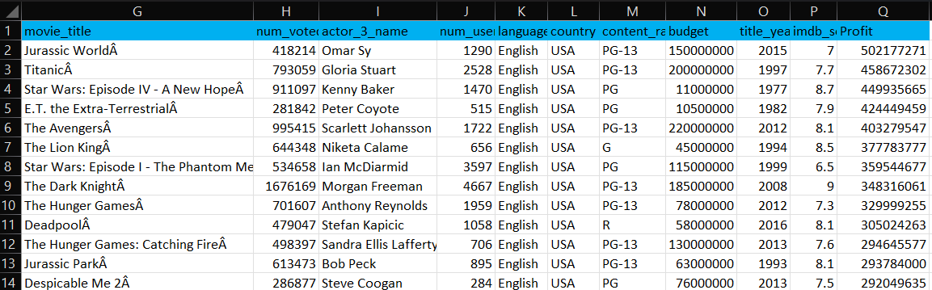

Based on the data available we can say that “Jurassic World” has made the maximum profit. “The host” is the outlier with budget 12,215 million and loss of 12,213 million. The host should be removed while performing the data analysis on the data because it’ll impact the statistical measures such as the mean and standard deviation. This can lead to incorrect interpretations of the data and inaccurate conclusions.

### Finding-2:

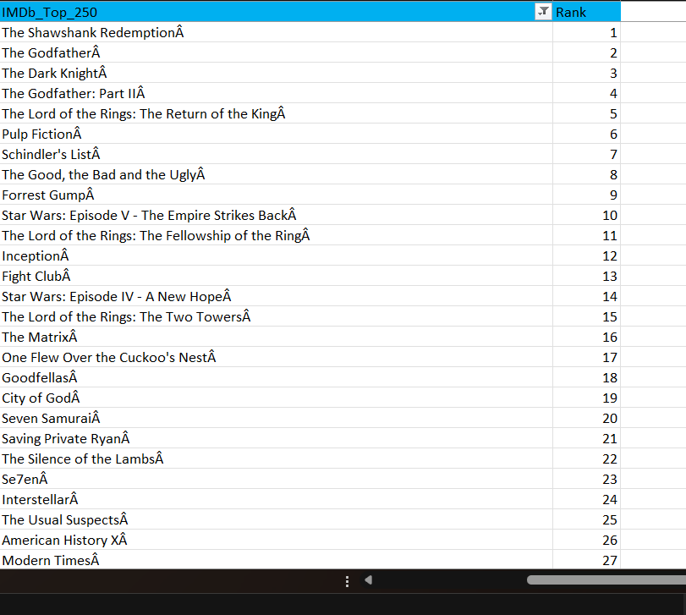

With the help of the given data, we can say that “The Shawshank Redemption” is get highest rating in the movies number of voted user is greater than 25,000 and get the rank 1. Number of voted user is taken greater than 25,000 because it ensures the consistent sample size and not influenced by outliers or irregularities in the voting pattern.

### Finding-3:

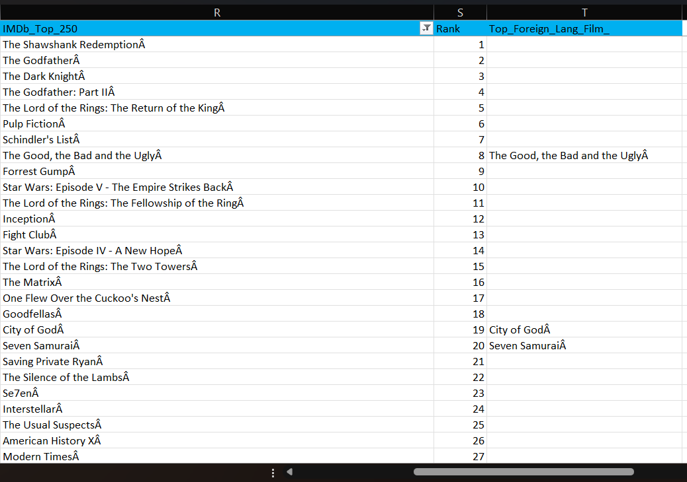

In the above figure column ‘T’ is including the name of the movies which are not in ‘English’ out of the top rated 250 movies which has number of voted users more than 25000.

### Finding-4:

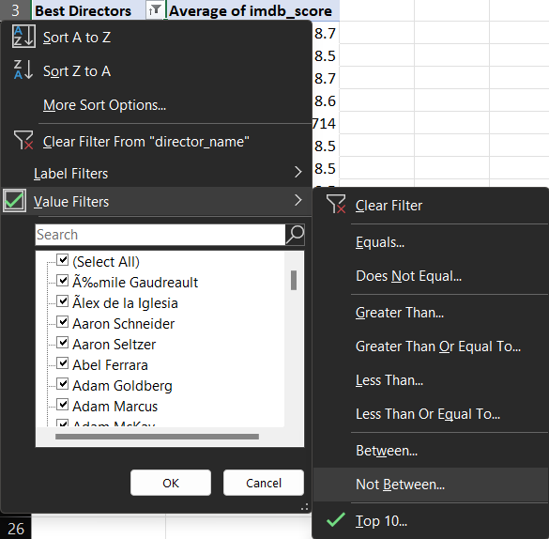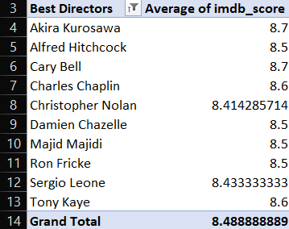

In the above figure pivot table function is used to calculate the top 10 directors name with highest Average value of IMDb score. “Akira Kur­osawa” and “Cary Bell” are the highest rated directors.

### Finding-5:

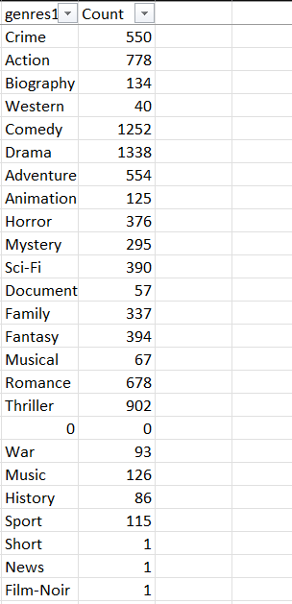

From the given data genre is counted using Count() function of Excel to get the popular genre. From the above table can say that ‘Drama’ is the most popular genre followed by comedy and then thriller.

### Finding-6:

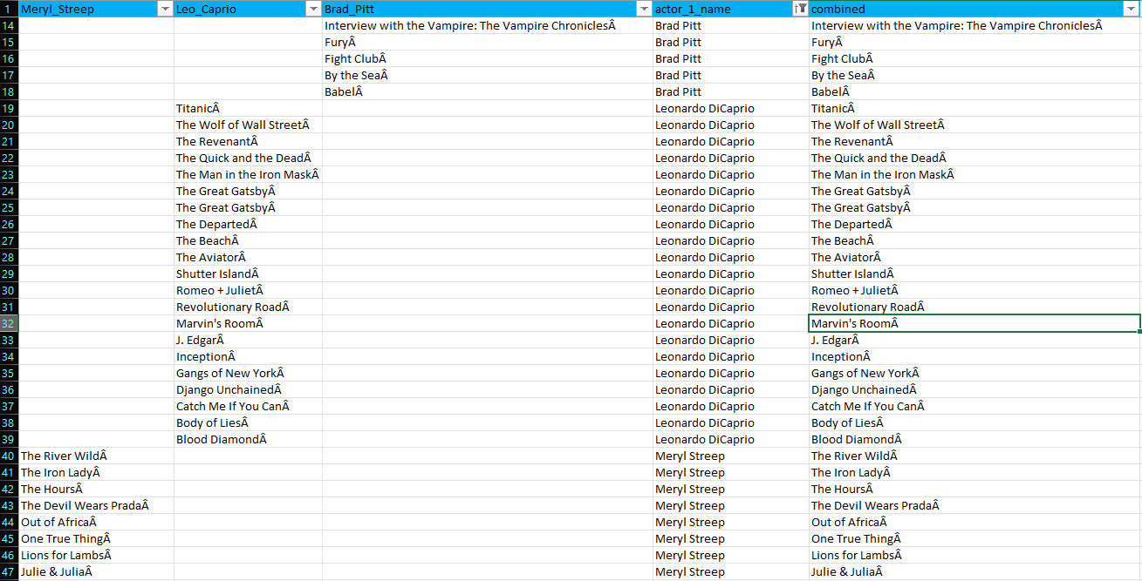

Above table is created to extract the movies of the ‘Meryl Steep’, ‘Leonardo DiCaprio’ and ‘Brad Pitt’. Their combined list is also displayed here. To get the name of the movies I here used IF() function of MS Excel.

### Finding-7:

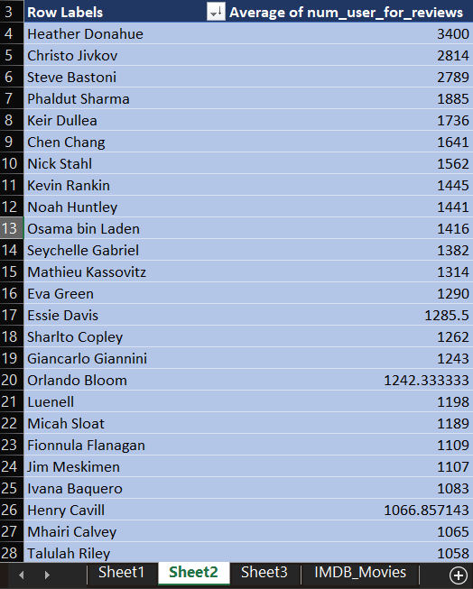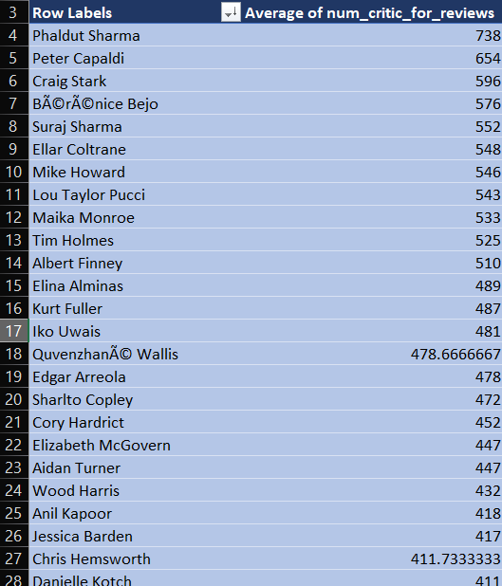

The above lists is extracted using the pivot table function of the Excel. Based on the above data we can say that actor who has the highest mean of the ‘number critics for review’ is Actor ‘Phaldut Sharma’. And actor who has the highest mean of ‘number user for reviews’ is ‘Heather Donahue’.

### Finding-8:

I extract the decade from the ‘title year’ column and calculate the number of voted users sorted in decades. From the above bar graph, we can say that 2000 is the decade where number of voted users is maximum.

## Data Analysis:

Several useful insights were obtained from the analysis. For example, Jurassic World has made the highest profit . The analysis also showed that movies Shawshank Redemption is highest rated movie on IMDb. Another interesting finding was that movies directed by Cary Bell and Akira Kurosawa tended to have higher ratings than others. The analysis also identified certain genres that were more popular than others.

## Conclusion:

In conclusion, I would like to tell that after doing a thorough analysis we were able to derive the insights from the data and was able to plot various graphs using that data. The data that once looked useless became useful and helped to find out the top rated movies and top rate directors. Also find the movies in other then in English language. Analyzing the data proved helpful in finding insight.

# Bank Loan Case Study

## Description:

The project aims to use exploratory data analysis (EDA) to analyze loan application data and identify patterns that indicate if a client has difficulty paying their installments. The project aims to understand the driving factors behind loan default, i.e. the variables which are strong indicators of default, and utilize this knowledge for the company's portfolio and risk assessment.

## Problem:

The loan providing companies find it hard to give loans to the people due to their insufficient or non-existent credit history. Because of that, some consumers use it as their advantage by becoming a defaulter. Suppose you work for a consumer finance company which specializes in lending various types of loans to urban customers. You have to use EDA to analyze the patterns present in the data. This will ensure that the applicants capable of repaying the loan are not rejected.

## Tech-Stack Used:

The project was performed using Excel version 2021 Excel was chosen for its powerful data analysis and visualization capabilities It is also widely used in the industry and provides a familiar environment for users.

## Findings:

### Finding-1:

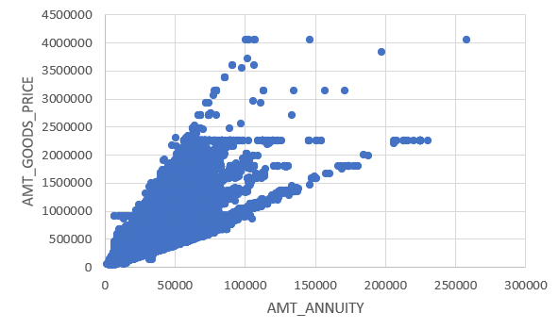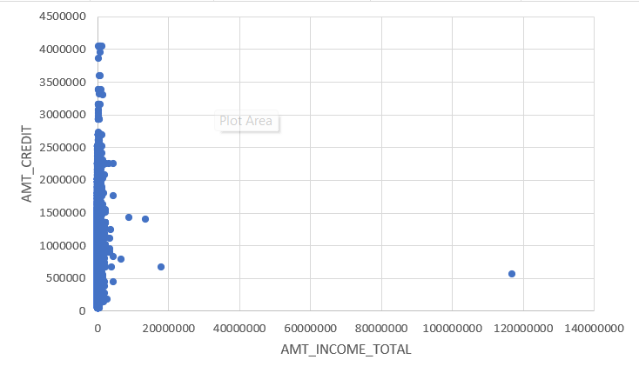

SK_ID_CURR 114967 is the outlier because his credit is very less as compare to his income. In second graph SK_ID_CURR 120926 is the outlier with respect to amount goods price and amount annuity. outliers can have a disproportionate impact on statistical measures such as the mean and standard deviation. This can lead to incorrect interpretations of the data and inaccurate conclusions so we should remove the outliers.

### Finding-2:

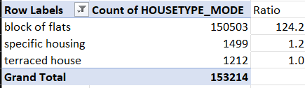

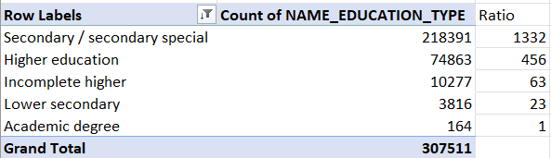

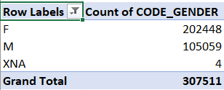

Above figures is used to find the data imbalance. I would suggest that we should remove the or use the specific data for the specific data. For example, to know the behavior we should analyze the male and the female differently so that female data isn’t affect the analysis because females are 2 times more than the male.

### Finding-3:

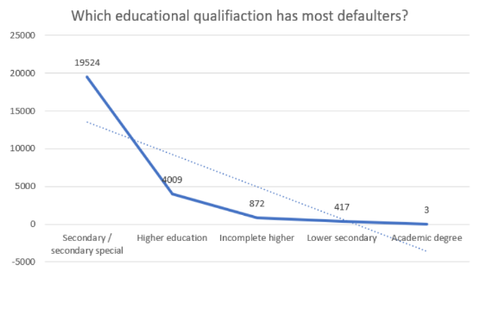

On the basis of the data given we can say that applicants with ‘secondary education’ have the most defaulters. I would suggest the bank to reduce the loan approval for the applicants who has ‘secondary education’.

### Finding-4:

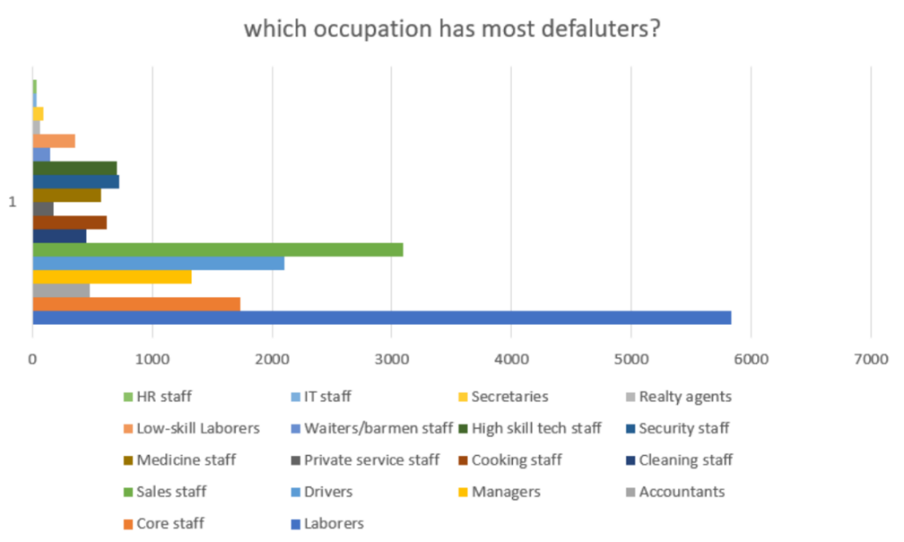

On basis of the data available we can say that occupation ‘Laborers’ has the most defaulters followed by the ‘sales staff’ and then drivers. ‘IT staff’ and ‘HR staff’ have the least number of defaulters. I would suggest that bank should give more loans to the applicants works into ‘IT staff’ and ‘HR staff’.

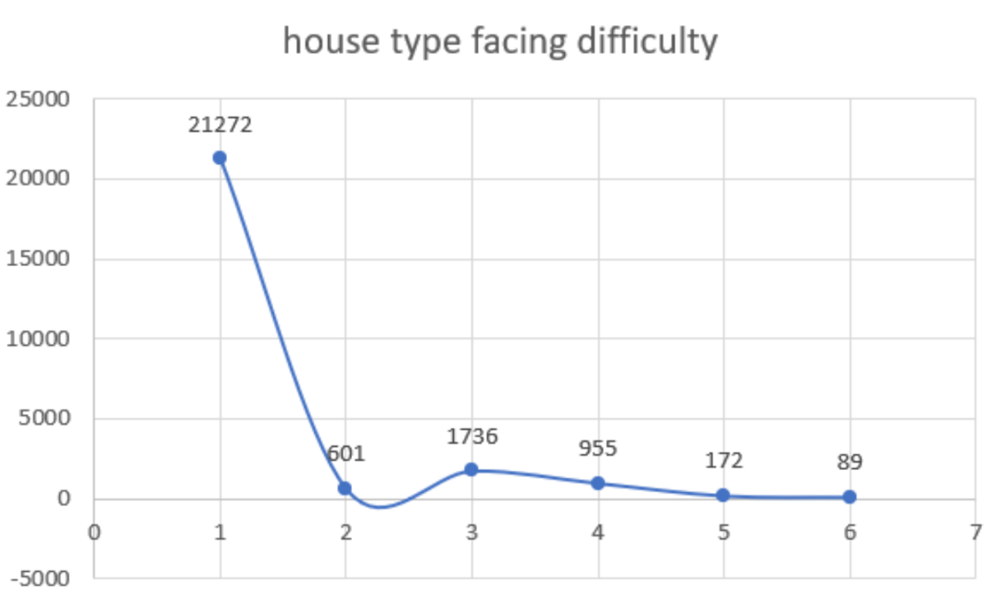

### Finding-5:

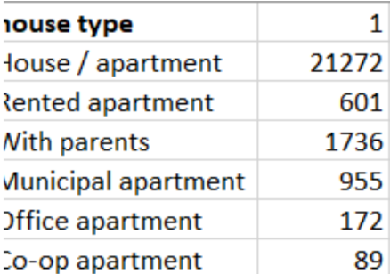

On the basis of the given data we can say that house / apartment house type has the most defaulters. And Co-Op Apartments has least defaulters, I would suggest we should give more loan to the residents of the Co-op Apartment.

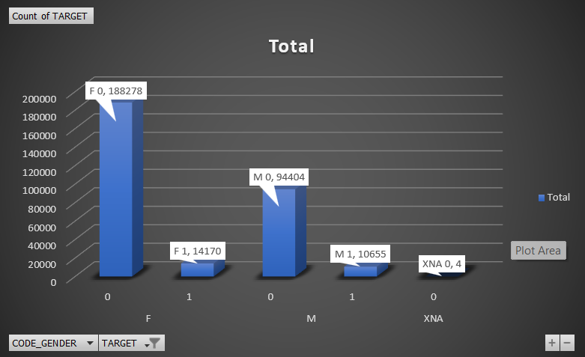

### Finding-6:

According to the above graph it is shown that although Females are more difficulties with payment but percentage wise it is male who face difficulties in payments. I would suggest the bank to give more loan to the females they default lesser as compare to the males.

### Finding-7:

In above bar chart it can be seen that client with payment difficulties has lesser number of days employed. I would suggest that Average days for number on employee should be more while deciding whether we should give loan or not.

### Finding-8:

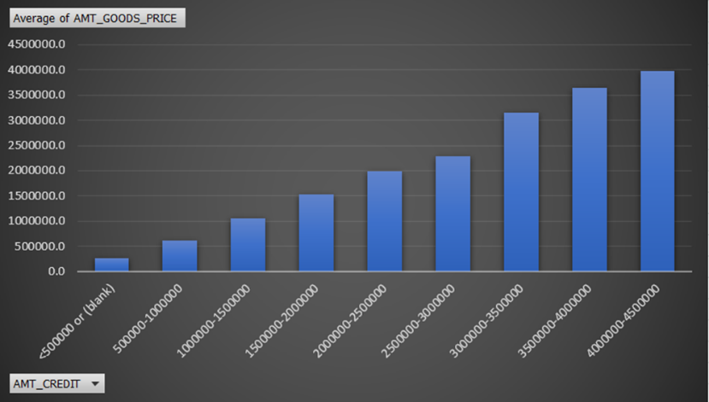

The adjacent bar graph show that Credit amount is increases with the increase of Good Price.

## Data Analysis:

The mean income for the income is around 160000. There is something wrong in the data the mean of the days_employeed in not acceptable. 8 percent people have difficulties in payments. It shows that Amt_Goods_Price and Amt_Credit are the most correlated variable followed by Amt_Annuity & Amt_Goods_price and Amt_Credit & Amt_Annuity. Although Females are more difficulties with payment but percentage wise it is male who face difficulties in payments. Here are more females than males. The ratio of male and female in around 1:2. The average of the income for male is more as compared to female. Academic degree holder applies for the loan most. Academic degree holder asks for more credit as compare to other educational background. Male ask for greater money for loan as compare to the female.

## Conclusion:

In conclusion, I would like to tell that after doing a thorough analysis we were able to derive the insights from the data and was able to plot various graphs using that data. The data that once looked useless became useful and helped to find out applicants who have difficulties in loan repayment. Analyzing the data proved helpful in finding various issues among the loan applicants.

# XYZ Ads Airing Report Analysis

## Description:

The project is based on a dataset of TV Ad Airings for some brands in the Automobile category. The aim of the project is to analyze the data and answer the given questions. The dataset includes various features like the network through which Ads are airing, the type of network like Cable/Broadcast, show name on which Ads got aired, Dayparts, Time zone, the time & date at which Ads got aired, Pod Position, duration for which Ads aired on screen, equivalent sales &, total amount spent on Ads aired. We will be analyzing this data to understand the different brands' share in TV airings, the change in brand share from Q1 to Q4 in 2021, conducting competitive analysis for the brands, and suggesting advertisement strategies for the brands.

## Problem:

Advertising is a way of marketing your business in order to increase sales or make your audience aware of your products or services. Until a customer deals with you directly and actually buys your products or services, your advertising may help to form their first impressions of your business. Target audience for businesses could be local, regional, national or international or a mixture. So, they use different ways for advertisement. Some of the types of advertisement are: Internet/online directories, Trade and technical press, Radio, Cinema, Outdoor advertising, National papers, magazines and TV. Advertising business is very competitive as a lot of players bid a lot of money in a single segment of business to target the same audience. Here comes the analytical skills of the company to target those audiences from those types of media platforms where they convert them to their customers at a low cost.

## Approach:

The approach to this project is to first clean the data and check for missing values. I then explored the dataset to understand the variables and their distribution. After that, I answered the given questions using different statistical techniques and visualizations. For example, I used descriptive statistics to analyze the variables and their relationship with each other. We will also use visualization techniques like bar graphs, pie charts, scatter plots, and heat maps to present our findings.

## Tech-Stack Used:

The analysis was performed using Microsoft Excel. We used different Excel functions, such as COUNT, COUNTIFS, SUM, UNIQUE and AVERAGE to perform the analysis. We also used PIVOT TABLE, SLICER in Pivot Table, CHARTS and GRAPHS to visualize the data.

## Findings:

### Finding-1:

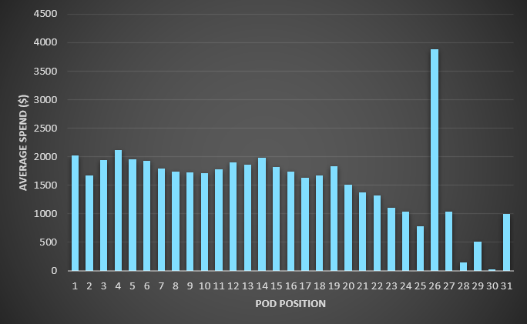

with the help of adjacent bar graph we can say that there isn’t any correlation between Average Spend and Pod Position. Although there is some trend in later parts, it seems decreasing but the value on 26 pod position is very high.

### Finding-2:

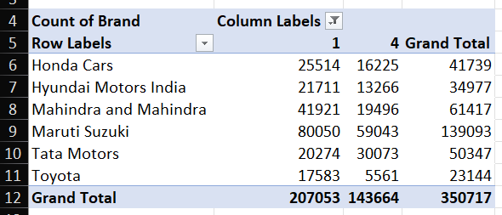

Based on available data, It seems that Maruti Suzuki is the most showed brand in TV airings followed by Mahindra & Mahindra and Honda. The least is Toyota. I would suggest that Toyota, Hyundai and Tata should increase their TV airing numbers. The share of various brands in TV airings changed from Q1 to Q4 in 2021. Tata Motors increased its share, while brands like Maruti, Honda and Toyota decreased their share.

### Finding-3:

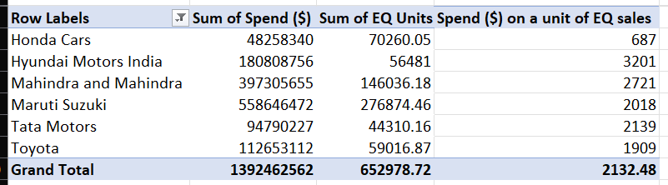

Based on available data, It seems that brand Honda spends the least for sales of a car on average. Hyundai, Mahindra & Mahindra and Tata Motors are the worst performing ad campaign because they spends the most to selling a car. Hyundai, Mahindra & Mahindra and Tata should try different strategy and combination to make it more effective.

### Finding-4:

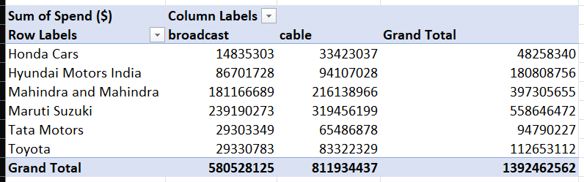

Based on available data, It seems that Honda runs the most successful ad campaign as it spend the less for a Equivalent sales. Honda’s maximum part of campaign is in the cable network type. I would suggest to other brand such as Hyundai and Mahindra & Mahindra to increase their cable budget.

### Finding-5:

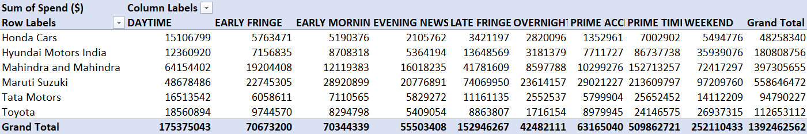

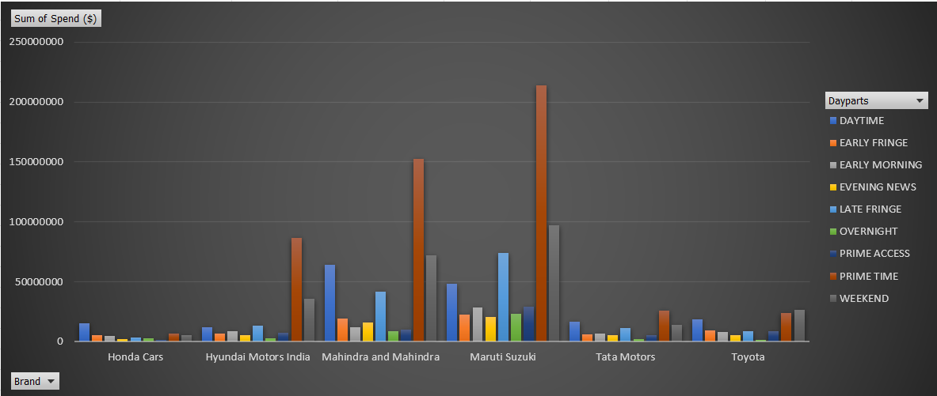

Based on available data, It seems that brand Honda spends the least for sales of a car on average and it’s maximum percentage of spend is on Daytime dayparts. I would suggest that Hyundai, Mahindra & Mahindra and Tata Motors should increase their Daytime daypart to increase their effectiveness.

### Finding-6:

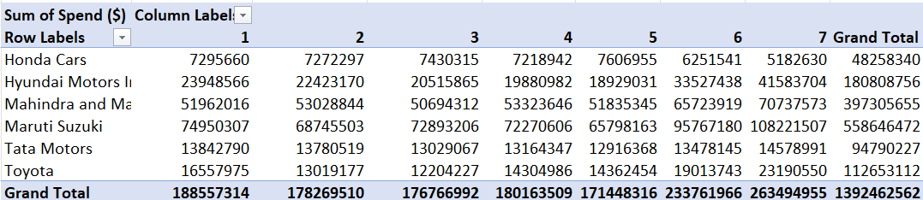

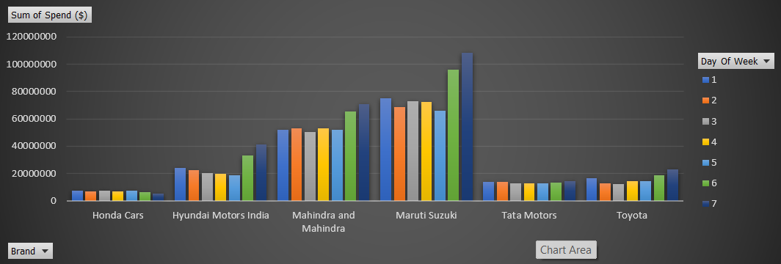

Based on available data, It seems that brand Honda spends the least for sales of a car on average and Honda’s spend throughout the week is same. I would suggest that Hyundai, Mahindra & Mahindra and Maruti should reduce their weekend spends.

### Finding-7:

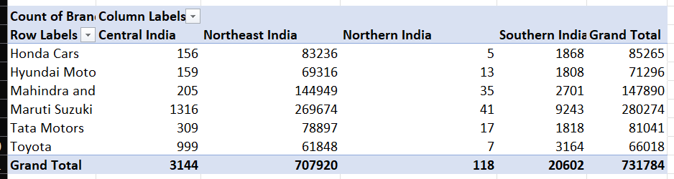

Based on the available data, Northeast India seems to be the target market for the ads. Therefore, I would suggest Mahindra and Mahindra to target this region in the digital ad campaign as well.

### Finding-8:

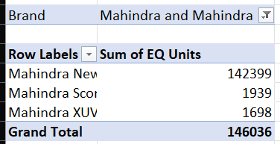

Based on the available data, Mahindra New Thar seems to be the most popular car in sales. Therefore, I would suggest Mahindra and Mahindra to focus on Mahindra New Thar in the digital ad campaign as well.

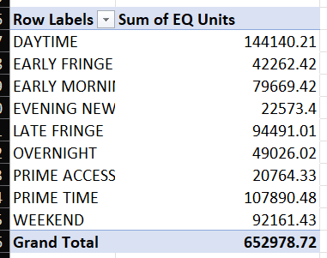Finding-9:

Based on the available data, the most effective dayparts for the TV ads are Prime Time, Daytime, and Late Fringe. Therefore, I would suggest targeting these dayparts for the digital ad campaign as well.

### Finding-10:



Based on the available data, the most popular ad duration for the TV ads is 30 seconds. Therefore, I would suggest Mahindra and Mahindra to target this duration for the digital ad campaign as well.

### Finding-11:

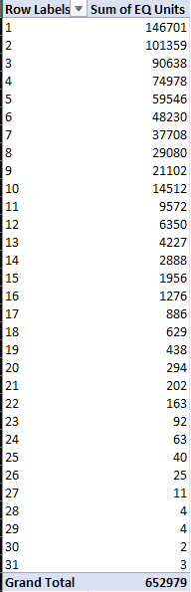

In terms of ad placement, the most effective pod position for the TV ads is 1. Therefore, I would suggest targeting this pod position for the digital ad campaign as well.

## Data Analysis:

Some of the insights we gained from the data are:

Based on available data, It seems that Maruti Suzuki is the most showed brand in TV airings followed by Mahindra & Mahindra and Honda. The least is Toyota. I would suggest that Toyota, Hyundai and Tata should increase their TV airing numbers.

The share of various brands in TV airings changed from Q1 to Q4 in 2021. Tata Motors increased its share, while brands like Maruti, Honda and Toyota decreased their share.

Based on available data, It seems that brand Honda spends the least for sales of a car on average..

Based on the available data, Mahindra New Thar seems to be the most popular car in sales. Therefore, I would suggest Mahindra and Mahindra to focus on Mahindra New Thar in the digital ad campaign as well.

In terms of ad placement, the most effective pod position for the TV ads is 1. Therefore, I would suggest targeting this pod position for the digital ad campaign as well.

## Conclusion:

In conclusion, I would like to tell that after doing a thorough analysis we were able to derive the insights from the data and was able to plot various graphs using that data. The data that once looked useless became useful and helped to find out the average number of airing of the ad of a brand and suggestion based on the data. Analyzing the data proved helpful in finding various issues among the brands.

# ABC Call Volume Trend Analysis

## Description:

The project is about analysing the Customer Experience (CX) Inbound calling team dataset for 23 days. The dataset includes various parameters such as Agent_Name, Agent_ID, Queue_Time, Time, Time_Bucket, Duration, Call_Seconds, and Call status. The goal of the project is to analyze the data and find insights that can help improve the customer experience and optimize the performance of the inbound calling team.

## Problem:

Inbound customer support is defined as the call centre which is responsible for handling inbound calls of customers. Inbound calls are the incoming voice calls of the existing customers or prospective customers for your business which are attended by customer care representatives. Inbound customer service is the methodology of attracting, engaging, and delighting your customers to turn them into your business' loyal advocates. By solving your customers' problems and helping them achieve success using your product or service, you can delight your customers and turn them into a growth engine for your business.

## Approach:

My approach towards the project was to first understand the dataset and identify the key metrics that can provide insights into the performance of the inbound calling team. I then used various data analysis and visualization techniques to analyze the data and find patterns and trends. Finally, I summarized my findings and provided recommendations to improve the customer experience.

## Tech-Stack Used:

The analysis was performed using Microsoft Excel. I used different Excel functions, such as COUNT, COUNTIFS, SUM, UNIQUE and AVERAGE to perform the analysis. I also used PIVOT TABLE, SLICER in Pivot Table, CHARTS and GRAPHS to visualize the data.

## Findings:

### Finding-1:

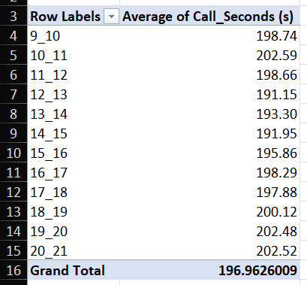

This pivot table includes the counts of the abandon calls also to filter it out “Call_Status” is used as filter. With the help of the given data we can say that calling time in morning and in the evening is high, company should train the agents to reduce the calling time. So less number of agents are required.

### Finding-2:

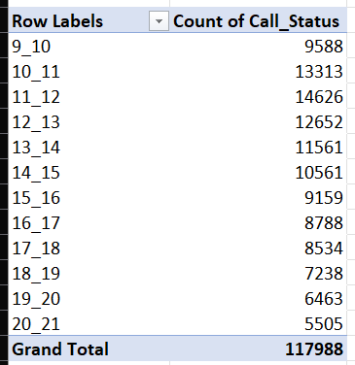

Based on the available data we can say that 12-13 hours is the busiest time. Between 10 am to 3 pm more than 50% of the calls are received. I would suggest that almost 50 % of the work force should be hired for the 10 am to 3 pm.

### Finding-3:

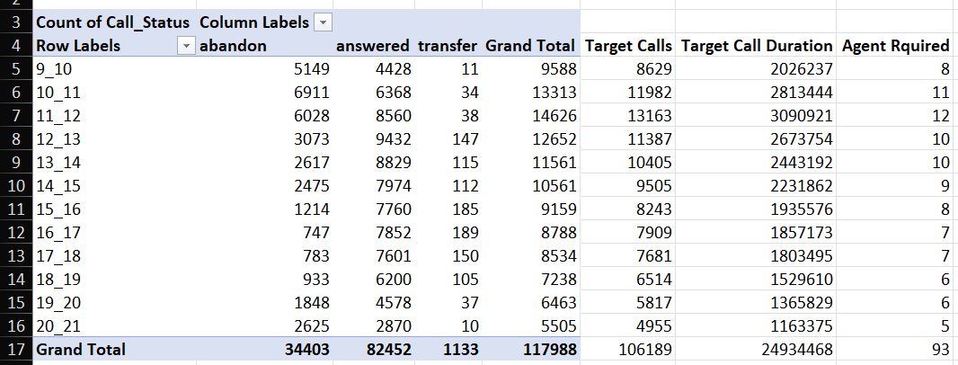

Based on the data available we can say that at least 12 agents are required in the time bracket 11am to 12 pm. If the agents are working 5 hours a week and take 4 leaves in a month also because data given here is for 23 days so for 30 days’ time span 93 agents a required.

### Finding:4

|  |  |  |  |  |  |
| --- | --- | --- | --- | --- | --- |
| Time Bucket Night | Ratio | Call_Counts | Target_calls | Average_call_Duration | Round off Agent Required |
| 9pm-10pm | 3 | 3539.64 | 3185.68 | 748034.05 | 3 |
| 10pm-11pm | 3 | 3539.64 | 3185.68 | 748034.05 | 3 |
| 11pm-12am | 2 | 2359.76 | 2123.78 | 498689.36 | 2 |
| 12am-1am | 2 | 2359.76 | 2123.78 | 498689.36 | 2 |
| 1am-2am | 1 | 1179.88 | 1061.89 | 249344.68 | 1 |
| 2am-3am | 1 | 1179.88 | 1061.89 | 249344.68 | 1 |
| 3am-4am | 1 | 1179.88 | 1061.89 | 249344.68 | 1 |
| 4am-5am | 1 | 1179.88 | 1061.89 | 249344.68 | 1 |
| 5am-6am | 3 | 3539.64 | 3185.68 | 748034.05 | 3 |
| 6am-7am | 4 | 4719.52 | 4247.57 | 997378.73 | 4 |
| 7am-8am | 4 | 4719.52 | 4247.57 | 997378.73 | 4 |
| 8am-9am | 5 | 5899.40 | 5309.46 | 1246723.41 | 5 |
| Grand Total | **30** | **35396.4** | **31856.76** | **7480340.467** | **30** |

To get 30% of the total calls which is 35396 because 30% calls are received at night. Then 35396 is divided into different time bucket according to the ratio given. On the basis of the given data we can say that if we want to answer 90% of the calls we should hire 30 agents to start night calling service.

## Data Analysis:

Call duration in the morning and also evening is higher as compare to the noon. I would suggest that company should try to decrease the call duration by giving agents proper training. This is how we can decrease the call abundance.

12 pm -1 pm is the busiest time. Infect between 10 am to 3 pm more than 50% of the call volume is received. For this reason, we should hire agents for the 10 am to 3 pm.

If the agents are working 5 hours a week and take 4 leaves in a month, 93 agents a required.

A total of 30 agents are required for the night calls to answer the 90% of the calls.

## Conclusion:

In conclusion, I would like to tell that after doing a thorough analysis we were able to derive the insights from the data and was able to plot various graphs using that data. The data that once looked useless became useful and helped to find out requirement of the agents to answer the calls and also to number of agent required to answer night calling. Analyzing the data proved helpful in finding various issues among the calling agent.

# appendix

**Link for** [**Data Analytics Process**](https://trainity.link/data/project01) **Project:**

[*https://drive.google.com/file/d/1VtfT-84OC51lD1DSb2oieSUHrKIwk7_Y/view?usp=share_link*](https://drive.google.com/file/d/1VtfT-84OC51lD1DSb2oieSUHrKIwk7_Y/view?usp=share_link)

**Link for** [**Instagram User Analytics**](https://trainity.link/data/project02) **Project:**

[*https://drive.google.com/file/d/1sfCCvmvw4s5sRGnHpEv7AvBs1t9oojYp/view?usp=share_link*](https://drive.google.com/file/d/1sfCCvmvw4s5sRGnHpEv7AvBs1t9oojYp/view?usp=share_link)

**Link for** [**Operation & Metric Analytics**](https://trainity.link/data/project03) **Project:**

[*https://drive.google.com/file/d/1E-PcuC-InAalAEX3_Ft59ZCo-GoBaPXb/view?usp=share_link*](https://drive.google.com/file/d/1E-PcuC-InAalAEX3_Ft59ZCo-GoBaPXb/view?usp=share_link)

**Link for** [**Hiring Process Analytics**](https://trainity.link/data/project04) **Project:**

[*https://drive.google.com/file/d/16x5NeKBkpdGgEaREGnkUks7X1i78kjxZ/view?usp=share_link*](https://drive.google.com/file/d/16x5NeKBkpdGgEaREGnkUks7X1i78kjxZ/view?usp=share_link)

**Link for** [**IMDB Movie Analysis**](https://trainity.link/data/project05) **Project:**

[*https://drive.google.com/file/d/1ToB5G-vDyyen4h82jooTZhoJnAnwABdN/view?usp=share_link*](https://drive.google.com/file/d/1ToB5G-vDyyen4h82jooTZhoJnAnwABdN/view?usp=share_link)

**Link for Bank Loan Case Study Project:**

[*https://drive.google.com/file/d/1BZCVamLw04Me6dxNygb71NXX2Seq4w3D/view?usp=share_link*](https://drive.google.com/file/d/1BZCVamLw04Me6dxNygb71NXX2Seq4w3D/view?usp=share_link)

**Link for XYZ Ads Airing Report Project:**

[*https://docs.google.com/presentation/d/10TP7_x_jOuTQpzmIvsuON4pV5Is7lRPt/edit?usp=share_link&ouid=111299441641572124265&rtpof=true&sd=true*](https://docs.google.com/presentation/d/10TP7_x_jOuTQpzmIvsuON4pV5Is7lRPt/edit?usp=share_link&ouid=111299441641572124265&rtpof=true&sd=true)

**Link for** [**ABC Call Volume Trend**](https://trainity.link/data/project08) **Project:**

[*https://docs.google.com/presentation/d/1DR8E1A5SMfw4lSVvbd03Foobs1Y_HtRJ/edit?usp=share_link&ouid=111299441641572124265&rtpof=true&sd=true*](https://docs.google.com/presentation/d/1DR8E1A5SMfw4lSVvbd03Foobs1Y_HtRJ/edit?usp=share_link&ouid=111299441641572124265&rtpof=true&sd=true)